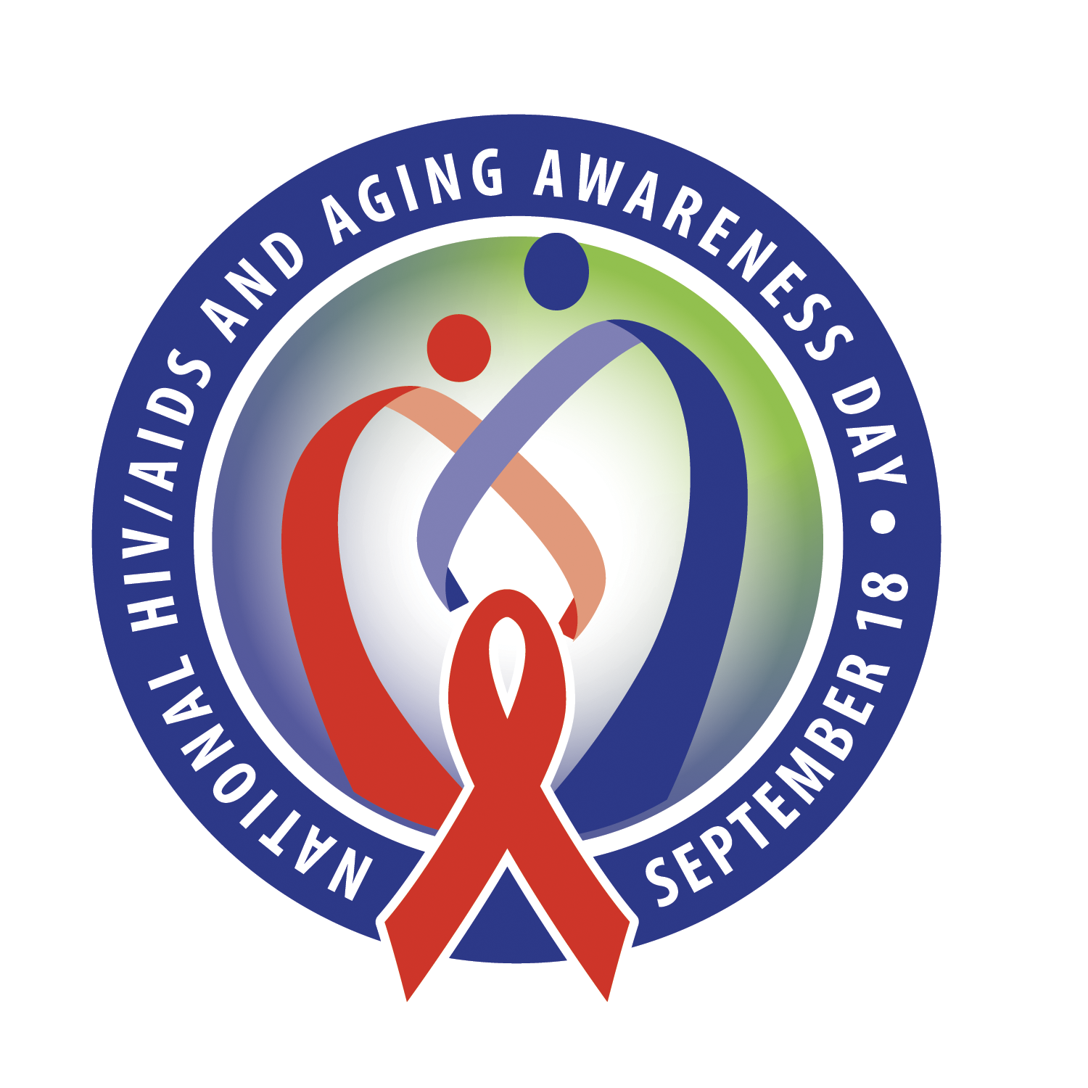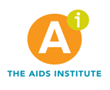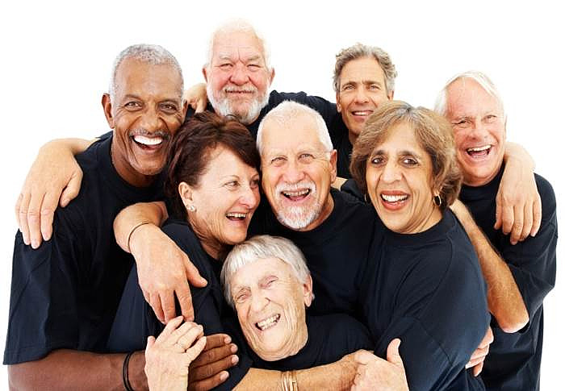

**September18th**

www.NHAAD.org|www.theaidsinstitute.org

**new diagnoses in the U.S. were in people aged 50 and older.**

in people aged 50 and older.

**1in6**

Customize Here

**Aging is a part of life; HIV doesn’t have to be!**

**National HIV/AIDS and Aging Awareness Day**